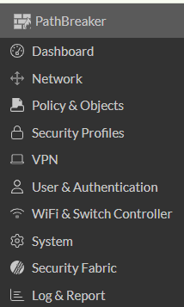

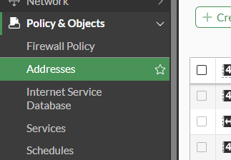

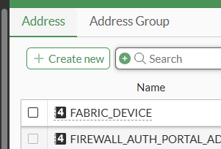

1. Block WhatsApp Using Router/Firewall (For Entire Network):
This method blocks WhatsApp for any device connected to your Wi-Fi network, but it doesn't rely on ChatGPT or other software on the device itself. It uses your router's settings to block traffic to WhatsApp's servers.
- Steps:
  - Log in to your router's admin interface (usually through a web browser like 192.168.0.1 or 192.168.1.1).
  - Navigate to the Firewall or Security settings.
  - Add blocking rules to prevent access to WhatsApp's servers:
    - You can block domains such as:
      - web.whatsapp.com
      - whatsapp.com
      - *.whatsapp.net
    - Alternatively, block the IP ranges used by WhatsApp, though these can change over time.
  - Apply changes and restart your router.

2. Using Parental Control Software:
There are various apps and services you can use on devices to block apps like WhatsApp:

On Android:
- Using Digital Wellbeing or Parental Controls:
  - Go to Settings > Digital Wellbeing & Parental Controls.
  - Tap Parental Controls and set up restrictions to block WhatsApp.
  - Alternatively, you can use third-party apps like Qustodio or Family Link for more detailed control.

On iOS (iPhone/iPad):
- Using Screen Time:
  - Go to Settings > Screen Time.
  - Tap App Limits and add a time limit for WhatsApp.
  - You can also go to Content & Privacy Restrictions > Allowed Apps and disable WhatsApp entirely.

On Windows or macOS (Using Software):
- Using Third-Party Tools:
  - Windows: Tools like Cold Turkey or Kaspersky Safe Kids can block apps or websites like WhatsApp.
  - macOS: You can use Focus (Mac App Store) to block specific apps, or OpenDNS to block the WhatsApp website.

3. Blocking WhatsApp at the DNS Level (Using DNS Filtering):
If you prefer a network-wide solution to block WhatsApp at the DNS level, you can configure your device to use a service like OpenDNS or Cloudflare Family DNS.
- Steps:
  - Go to Settings > Network & Internet > Wi-Fi (on Windows) or Settings > Wi-Fi (on macOS/iOS).
  - Modify your DNS settings to use a custom DNS server:
    - OpenDNS: 208.67.222.222 and 208.67.220.220
    - Cloudflare Family DNS: 1.1.1.3 (blocks adult content, may help block WhatsApp)
  - Follow the setup guides on the OpenDNS or Cloudflare website to block specific websites.

4. Use Device-specific App Management (App-Specific Blocking):
If you want to block WhatsApp specifically on a device:
- On Android:
  - You can go to Settings > Apps > WhatsApp and force-stop the app or uninstall it.
- On iOS:
  - Go to Settings > General > iPhone Storage and find WhatsApp, then delete it.
- Block Notifications or Limit App Usage:
  - On both iOS and Android, you can limit WhatsApp usage via built-in features like Screen Time or Digital Wellbeing. You can also restrict notifications or completely block the app during certain hours.

5. Blocking with Third-Party Apps (for any platform):
There are a variety of apps that offer customizable blocking options for any platform. Here are a few you could consider:
- Freedom: Works on Windows, macOS, Android, and iOS. Allows you to block apps, websites, and other distractions.
- Net Nanny: Allows for full monitoring and blocking of specific apps and websites across different devices.
Would you like further guidance on any of these methods or specific step-by-step instructions for your device?

